**The programme of the European Master in Social Work  
  
1st semester** in Groningen (the Netherlands) and Odense (Denmark):

Comparative Social Policy in Europe,

English Language & Intercultural Communication in Social Work

Project Management

Distance Learning

In the **2nd and 3rd semesters**: a choice of

2 elective programmes each semester in a

different country:

* Freiburg (Germany)

Intercultural Social Work

Gerontology / the elderly

* Vilnius (Lithuania)

Social Work and Human Rights  
Globalization, Europeanization and Social Policy

* Groningen (The Netherlands)

Psychosocial Rehabilitation  
Labour and Social Inclusion

* Odense (Denmark)

European Knowledge Developments

in Social Work - deepening module

European Social Politics

Children and Youth at Risk

* Málaga (Spain)

Community intervention in Social Work  
Social Law and Social Protection

* Gabrovo (Bulgaria)

European Labour Market Policies  
Social Dynamics in an Enlarging Europe

4th semester:

A thesis and a graduation assignment will complete the study.

It is also possible to study separate electives for €1250 each. You will receive a certificate.

More information:

[www.europeanmaster-socialwork.eu](http://www.europeanmaster-socialwork.eu)

or contact:

Mr. L.M. Gijsbers  
Programme manager European Master in Social Work  
e-mail: [l.m.gijsbers@pl.hanze.nl](mailto:l.m.gijsbers@pl.hanze.nl)

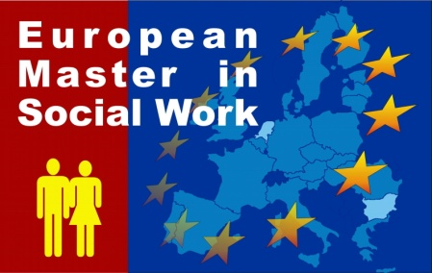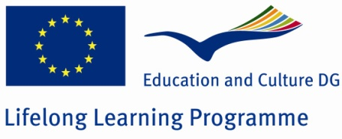

European

Master in

Social

Work

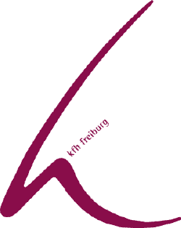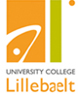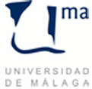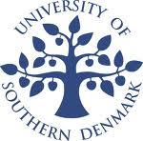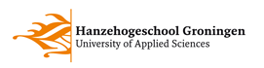

**What is the European Master in Social Work?**

The European Master in Social Work is a 2 years study programme in

6 countries in Europe to graduate you as a Master in Social Work.

In this study programme courses are being offered from a European perspective on social inclusion and combating poverty. There are modules offered on various welfare systems and different approaches of Social Work in different parts of Europe.

**When?**

The Master Course will start in September 2012 in Groningen, The Netherlands.

**Is the European Master in Social Work interesting for you?**

It is specially designed for those who want to improve skills in various fields, such as:

* Intercultural Competencies
* Community Development
* Children and Youth at Risk
* Ageing in Europe
* Labour and Social Inclusion
* Social Rehabilitation
* Social Policy in Europe

In our curriculum you can find a lot of interesting modules that combine studying, social work practice and intercultural experience in different countries.

**Tuition fee**: Year 1: € 6.000

Year 2: € 4.000

Scholarships will be available Conditions:

see www.europeanmaster-socialwork.eu

**How is the study programme organized?**

Every semester starts with a meeting week introducing the study programme in one of the cities involved in the project.

In this week you will meet your study partners from the other countries and your teachers.

During the meeting week you will create agreements with each other on the drafting of assignments on-line during the next 12 weeks. After

3 months there is a new meeting planned in one of the participating Universities.

**In two years you will visit**

**4 – 6 universities and university colleges around whole Europe!**